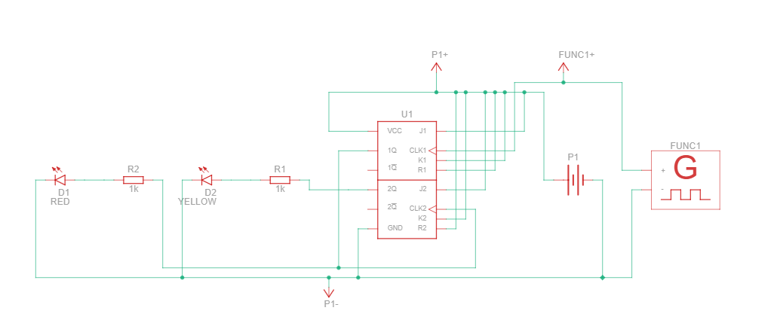
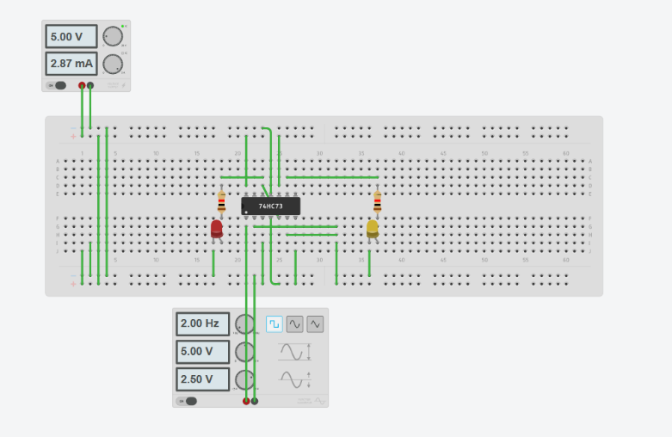
Lab 3: Sequential Circuit Design
2-bit flip-flop counter by using JK flip flop.

When start the simulation, the LEDs will cycle through binary numbers:
Clock Pulse | Bit 1 (2Q) | Bit 0 (1Q) | Decimal Value
Initial | Off (0) | Off (0) | 0
1st Pulse | Off (0) | On (1) | 1
2nd Pulse | On (1) | Off (0) | 2
3rd Pulse | On (1) | On (1) | 3
4th Pulse | Off (0) | Off (0) | 0 (Resets)

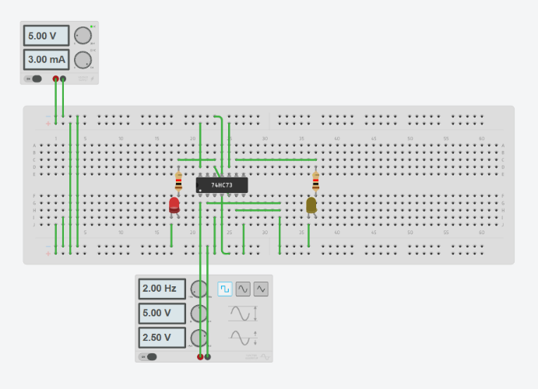
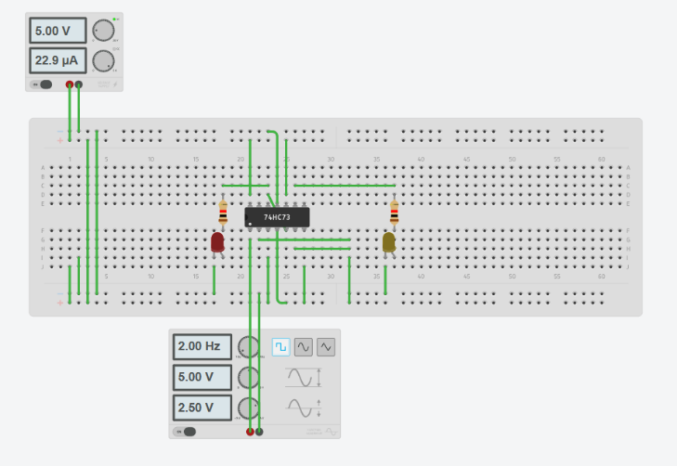
Initial First Pulse

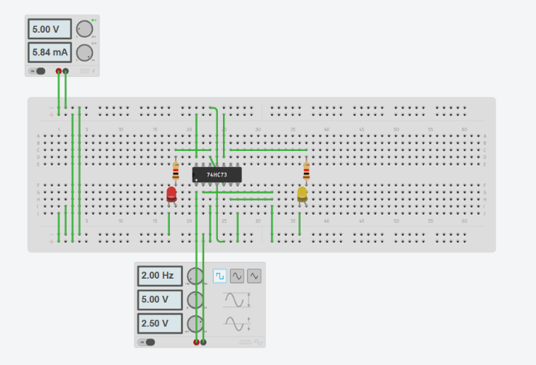
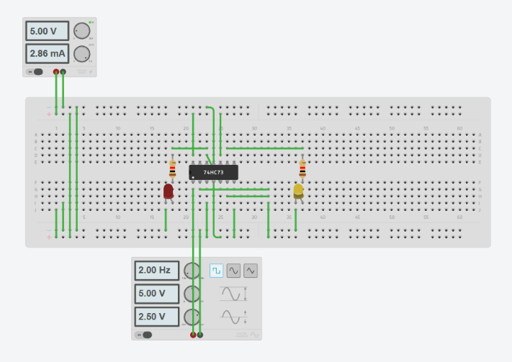
Second Pulse Third Pulse
Lab Practices:
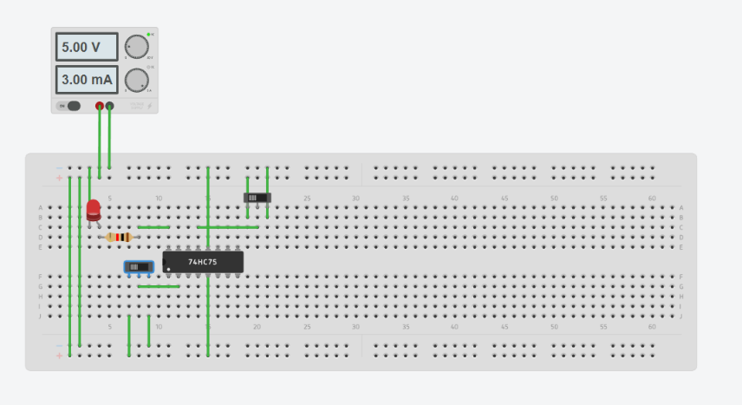
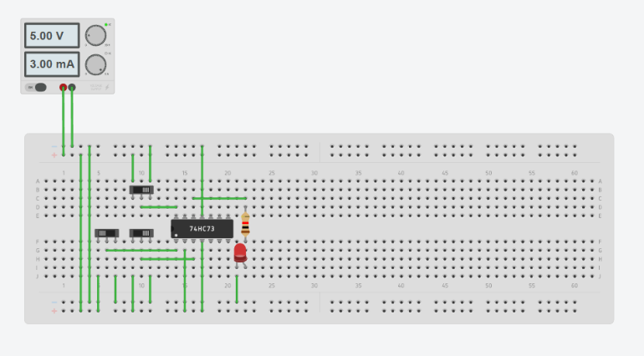
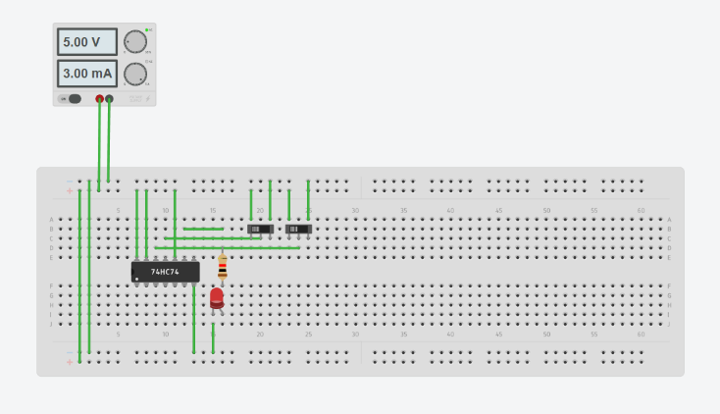
1. D flip flop
2. J-K flip flop
3. 4-bit Lash

